Sample Project Documentation: ServiceNow Data Import & Analytics
Date: 30 September 2026 | Team ID: 6ab4ae09a238dc999eb4ccf4
Project Name: Import Data using Transform Maps (Spreadsheet)

Project Description & Executive Summary
This project focuses on importing structured data from an external spreadsheet into the ServiceNow platform using Import Sets and Transform Maps. The project simulates a real-world scenario where bulk employee data is received in Excel format and must be migrated into ServiceNow efficiently and accurately. The spreadsheet data is first loaded into an Import Set table (u_employee_import), which serves as a staging area, and a Transform Map (Sample Spreadsheet Import) is then configured to map source fields to the target table fields (u_employee_test). Upon executing the transformation, records are created in the target table and validated to ensure data integrity.
A critical milestone of this implementation is the configuration of Coalesce on the Employee ID field. This prevents duplicate records during periodic re-imports, correctly routing modifications (e.g., email or name changes) as database updates, inserting new employee records, and safely ignoring unchanged rows. Finally, the project builds an executive analytics suite featuring Department distribution (Pie Chart), Location distribution (Bar Chart), and a tabular List Report consolidated onto an executive Performance Analytics Dashboard (PA_DASHBOARDS).
Milestones & Phased Execution
Phase | Phase Name | Technical Summary
Phase 1 | Prepare the Sheets | Constructed Sample Spreadsheet.xlsx with 15 initial employee records.
Phase 2 | Create Custom Table | Created custom table u_employee_test with 5 String columns and configured Form Layout.
Phase 3 | Import Set Table | Navigated to System Import Sets > Load Data; created staging table u_employee_import.
Phase 4 | Create Transform Map | Created Transform Map 'Sample Spreadsheet Import'; mapped 5 fields via Auto-Map.
Phase 5 | Transform & Validate | Executed Transform; verified completion code 'Success' with 15 total rows, 15 inserts.
Phase 6 | Enable Coalesce | Navigated to Field Maps; marked Coalesce = True on u_employee_id to enforce idempotency.
Phase 7 | Delta Data Ingestion | Uploaded spreadsheetproject.xlsx (4 rows: 2 updates, 2 inserts). Re-run produced 4 ignored.
Phase 8 | Create Reports | Constructed Report 1 (Dept Pie Chart), Report 2 (Location Bar Chart), and Report 3 (List Report).
Phase 9 | Add to Dashboard | Enabled ACL Admin Overrides on pa_dashboards and assembled the multi-chart dashboard view.

Analytical Reports Visuals
Report 1: Employees by Department (Pie Chart)
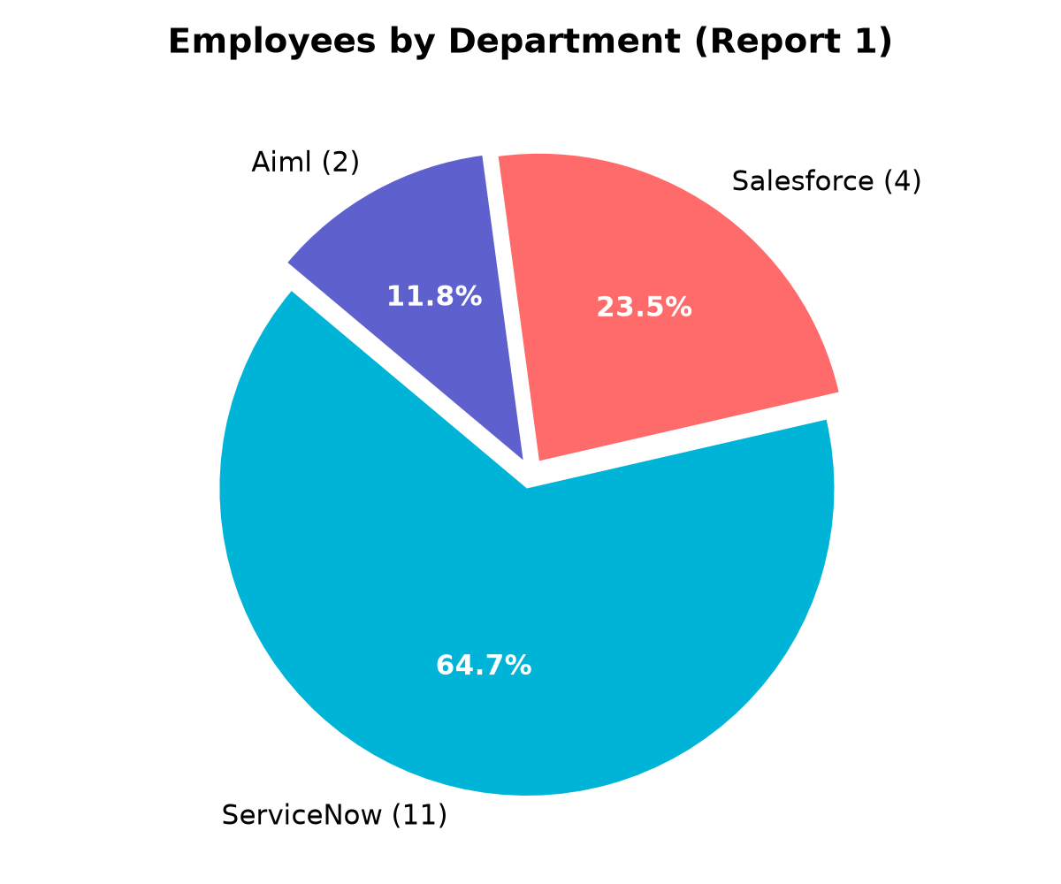
Report 2: Employees by Location (Bar Chart)
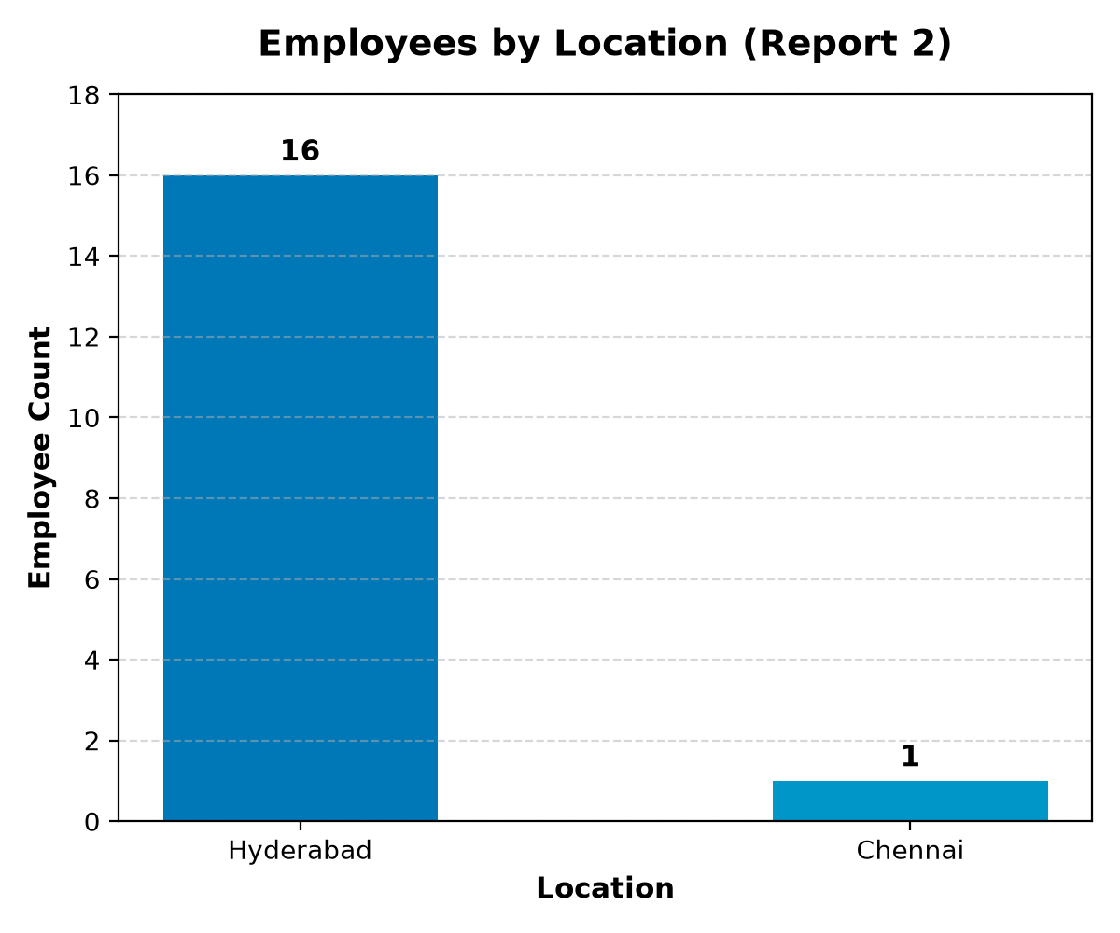
Consolidated Employee Analytics Dashboard View


